Research - ICOM 4998 (March 29- April 2)

Solar District Cup

Jeziel E. Torres Vazquez

Email: [jeziel.torres1@upr.edu](mailto:jeziel.torres1@upr.edu)

**Abstract: This week the team found out how to solve the overload and overvoltage problem. Then it connected the battery to the OpenDss circuit.**

**1 Introduction**

In the past week the Distribution System Impact Analysis had some problems with the production of the PV arrays. This production made the transformer overload. Because of this the team asks the design team to downsize the system so the transformers don't overload. This week the team was trying to figure out how to solve this problem so the system doesn't have to be downsized.

**2 Work done in the week**

Last week the design team downsized the system to see if the transformers didn't overload any more. The OpenDss team tries every possible solution to make the system stable without downsizing it, but it wasn't possible. The design team asked our team to seek a possible solution because the system was downsized many times. This was a problem because the system was too small for the amount of load the Auraria Campus had.

The OpenDss team arranged a meeting to focus on the problem. In the meeting discussed possible solutions for this problem. The team stated that the HeatSprings videos should be watched to see any errors in the code. The videos were divided in equal part so all the members could help seek the solution to this huge problem.

The video that the team assigned me was “Importance and Approach to Distribution System Impact Analysis and OpenDSS”. I started watching the assinsged video to see ant problems with the code or implementation of the PV arrays or production. Dr. Latif started talking about how to connect the PV arrays to OpenDss. He mentioned that the kV of the transformer is important because if this value is set wiring the transformer could overload and cause problems.

He mentioned that to establish that value the node on the PV arrays connections have to be used to set the transformer value. With this I check on what node the PV arrays where connected and the transformer kV value. The transformer value was wrong. This value was set to 0.416kV, because of this the transformer overload. It wasn't enough kV so the transformer could resist the new load added to it. The team computed this value and established the correct value was 12.47kV. When the value was corrected the simulation was run and there were no problems. All the overloads and overvoltages were fix and the design team could implement the original design.

Also the OpenDss team got the battery specs. With these values ther battery was connected and tested for any possible problems. These simulations ran smoothly and there were no problems. The battery did not suffer any losses or overvoltages.

**3 Graphs, tables, and picture**

This figure is the Production of all the solar panels for the entire year.

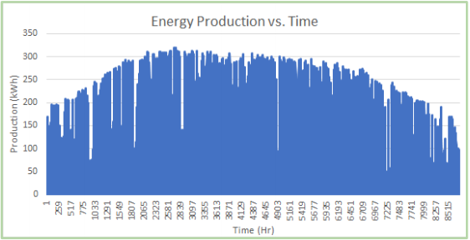

This is the losses the battery had when connected to the system.

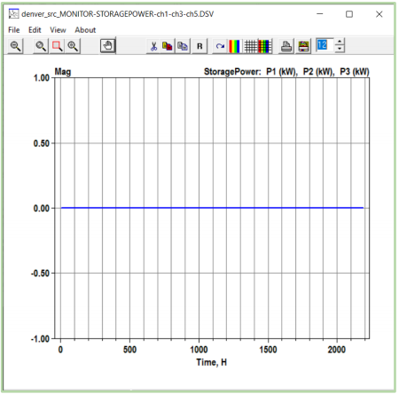

**4 Conclusion**

Because of the HeatSpring videos the problem was corrected. This is important because we need to learn from the experts. The video helped the team to find the error on the code and corrected so the original design could be used. Because this is done the Distribution System Impact Analysis can start writing the final report to be delivered for the competition. This will start next week.